**Starcraft AI Bot**

A recent trend that has been occurring in the CS world is the creation and use of bots. Bots can be used for a variety of things, from trying to reserve a high demand product when it is released (like the new Xbox and PS5), automating tedious and mindless work (I used this for some conversions at work), or even for creating opponents in video games.

Bots in video games have technically been around for a while. When computers were first created, there was quickly interesting in creating an AI that could play chess. Also, most single player games have some form of AI used in enemies that the players have to overcome. More complicated AI can be used to simulate other players in competitive strategy games such as Age of Empires.

However, with the recent popularization of Deep Learning, the heights that AI can reach has vastly expanded. Recently, DeepMind created a Starcraft bot called AlphaStar with deep learning. What this essentially means is that AlphaStar was shown thousands of examples of StarCraft games, and with that data used algorithms to create ‘neural connections’ and with that information make informed decisions on best how to play.

It would be an understatement to say that it was successful. As you can see from the graph below, it managed to increase its ranking past grandmaster in less than 2 weeks. If you play competitive games, you start to see how astounding this is. I personally don’t play Starcraft, but I play chess competitively online and if I’m doing unusually well, it takes me about 2 weeks to jump up 100 points in rank. Granted Starcraft is a different game and has a different scale, but the point is that it takes a lot of dedication to get good at these competitive games. Technically speaking AlphaStar did do a lot of grinding since it had to process through all that data, but it is also a computer so it doesn’t get tired and can work much faster than a human can.

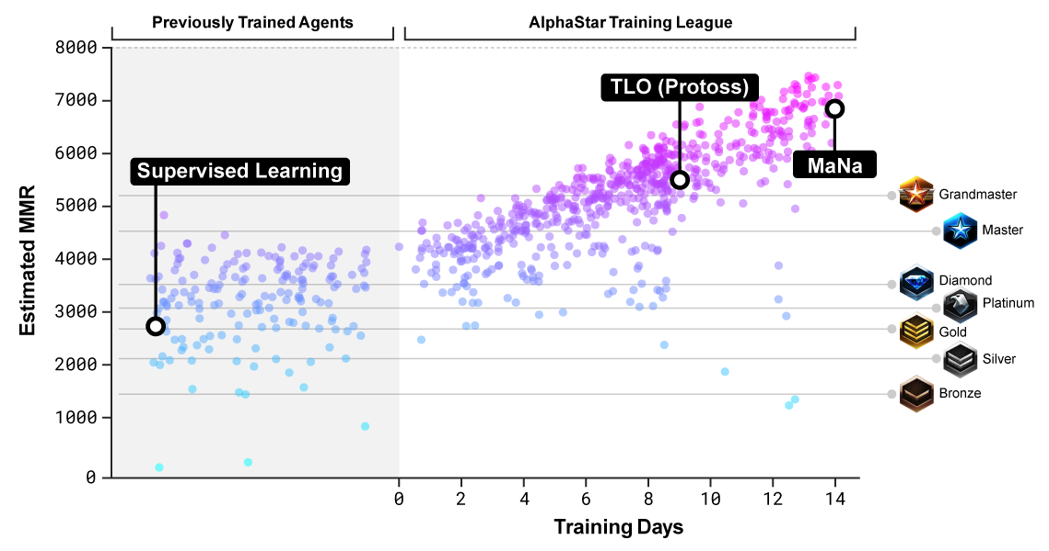

The ethics of using this bot against real players does raise some ethical questions, the main one being of unfair advantage. Is the playing field of this bot really the same as the human players? DeepMind did state that they did take steps to ensure that it played like a human. One example of these steps is when AlphaStar receives information that it can act on, there is a small delay inserted to simulate the processing time of a human. With a bunch of these limitations in place, you could argue that they’re on the same playing field.

However, there are still some gaps between how the computer sees things and how human players see them. For example, when human players are playing StarCraft, they can only see the part of the map that is enclosed in their monitor. AlphaStar on the other hand can see the whole map at all times (granted, only the parts of the map that have been explored by its troops). This could be seen as unfair since AlphaStar would be more aware of incoming enemy troops and would thus be able to respond faster.

This issue of speed comes up rather frequently. Another example of a human limitation that AlphaStar avoids is when a player spam clicks a location for their units to move. It’s a very human thing that a lot of people do but wastes lots of time. AlphaStar is very efficient in just telling the unit to move once, and then goes to work on other things. In more complex battles, AlphaStar could also micromanage the individual units much more efficiently than a human could.

There are a bunch of advantages that AlphaStar has over humans, but it also has some limitations which adds to our questioning of the even playing field. One limitation is the fact that AlphaStar has only been trained on one faction. If AlphaStar was to play as another faction it would most certainly lose just because it hasn’t trained on data with that faction yet. AlphaStar can also only deal with things it’s encountered before, if it sees a completely new situation it wouldn’t be able to take what it’s learned previously and apply it, it would just be confused and potentially freeze.

Let’s jump into the ethics a little deeper and talk about some of the prima facie involved. The first one would be Non-injury. This is a bot, playing a video game. One could argue that it is hard to see how what harm it would do beyond bruising a gamers ego. However, things could get more complicated. What if the bot was used in a competition that involved money? If it is true that it’s not on an even playing field, then it is essentially cheating another human player out of their prize money. I think the overall importance of the Non-injury prima facie is predicated on what this bot will be used for.

The second prima facie, which I feel like highlights the benefits of AlphaStar would be self-improvement. We are always trying to expand the limits of computers, and AlphaStar shows great promise in the field of Deep Learning. Granted, having a machine being really good at a video game isn’t in itself useful, but what the researchers learnt and published while creating this bot could be used to create a bot that would be helpful to society. For example, maybe in the future they could create a bot that would analyze economic markets and could better inform consumers. Of course, having a bot opens up a whole new can of worms in regards to ethics, but the point is by exploring the use of deep learning with video game bots, we could open up a lot of possibilities as a society.

The last prima facie that comes into question is veracity. This seemed to be a point that was focused on a lot in the ‘Don’t Expect AI to Play Like a Human’ article. One of the biggest issues with AlphaStar is that it’s playing a competitive game with humans but has extra advantages. This was discussed earlier, but this bot is somewhat expected to behave like a human but is able to cut corners with it’s processing power, unlimited map view, data API’s ect. In a sense AlphaStar could be seen as lying about what it really is and is in violation of the fidelity of the playing field which is expected from players on competitive games.

Lots of these prima facie come connected with potential neutralizations. For example, the prima facie of non-injury naturally comes with denial of injury. This argument was highlighted earlier, but one could argue that a bot being really good at video games doesn’t harm anyone. Another rationalization that is tied with an already explained argument is appeal to higher loyalties. This argument could easily be tied with the self-improvement prima facie. The creation of this bot and this lesson learnt could have higher implications than just being able to play a video game. For example, if this bot could be considered unethical in the gaming community, it doesn’t matter because it’s research for something more important than video games.

A potential neutralization whose argument hasn’t already been explored with prima facie could be denial of victim. Lots of gamers can be arrogant, and the ones at the top might feel like their better than everyone else. People who play competitive games know that elitism can get out of control and makes it hard for new players to get started. Some might say that these really good players deserved to be beaten by this bot because they could use a slice of humble pie. I personally don’t think this is a very strong neutralization, but it still could be one that comes up.

In conclusion, AlphaStar showcased some very exciting technology, but with new technologies comes the questions of ethics. Is it okay for this to be introduced into the gaming world, or could it be considered unfair? I think as deep learning continues to progress, we will see more of these bots in the future and will have to answer these questions.

Sources:

<https://deepmind.com/blog/article/alphastar-mastering-real-time-strategy-game-starcraft-ii>

<https://en.wikipedia.org/wiki/AlphaStar_(software)>

<https://www.pcmag.com/opinions/unfair-advantage-dont-expect-ai-to-play-like-a-human>